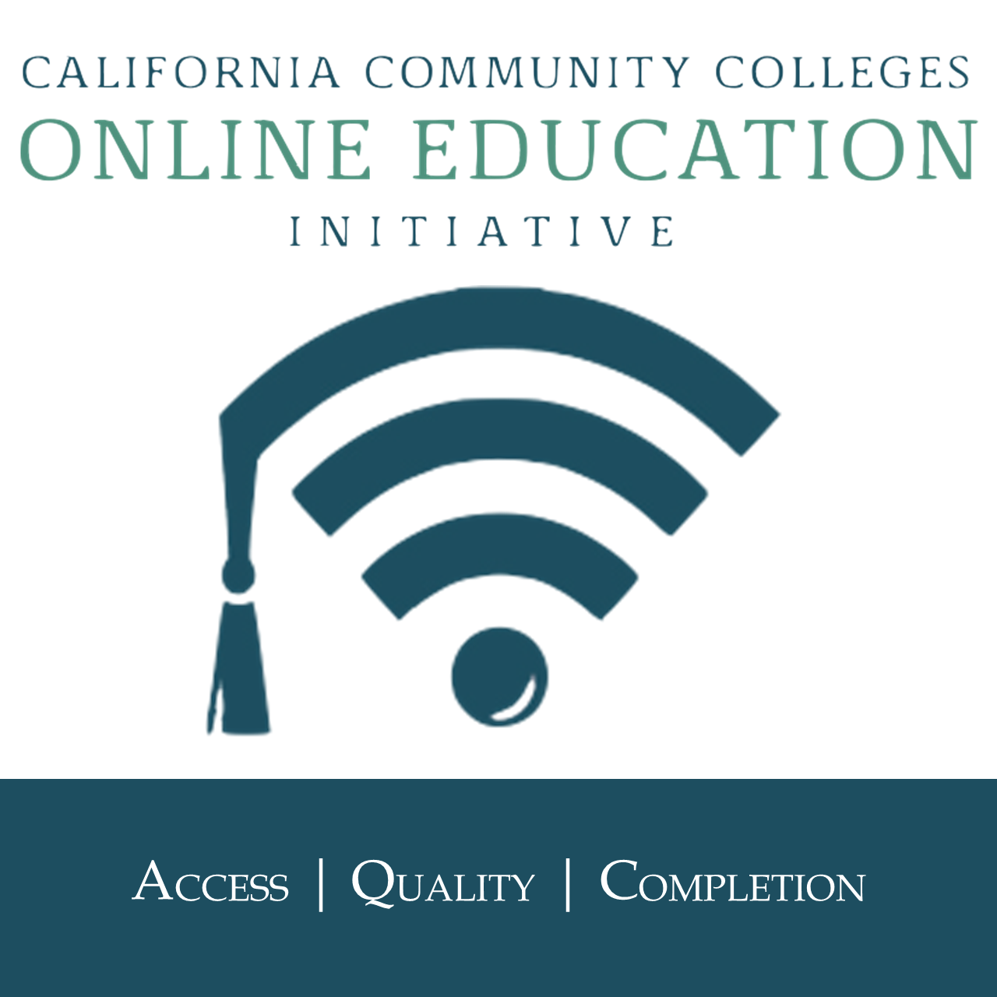

OEI Consortium Meeting Agenda
Friday, May 11, 2018
Embassy Suites Sacramento - Riverfront Promenade
10:00 AM - 3:30 PM

- Review of Agenda
- Approval of Minutes
- OEI Update - Jory Hadsell
- Consortium Expansion - Kate Jordahl

- Summer 2018 Update - Jory Hadsell, Andrea Hanstein, Jay Field

- Recognitions - Kate Jordahl

Working Lunch

- Then and Now - Five years of Collaboration

- Professional Development - Autumn Bell

- Academic Affairs - Barbara Illowsky/Marilyn Harvey

- Student Services - Bonnie Peters

- OEI Highlights - share what is working well at your schools

- Calendar Planning
  - June Virtual meeting Consortium meeting will be Friday, June 15,
9:30-11:30
  - Possible meeting calendar for 2018- 2019
    - Aug 9 - virtual
    - Sept 14 - Sacramento
    - Oct 19 - virtual
    - Nov. 9 - Sacramento
    - Dec. 14 - virtual
    - Jan. 18 - virtual
    - Feb. 22 virtual
    - Mar 8 - Sacramento
    - April 19 - virtual
    - May 10 - Sacramento
    - June 21 - virtual

Reimbursement Information: https://public.3.basecamp.com/p/Tpxwk87wgKnF9qfXSEanpYvu

